**Python coding challenge**

**Name: V. SreeVidya Date: 20-12-2023**

**Questions:**

Coding Assesment:

1.Explain Python Module with examples  
a. Import module in Python  
b. Renaming the Python module

2.Explain Pandas and numpy using Examples in PYTHON

**1.Module:**

module is a file containing set of functions which we want to include in our application

Import: Import keyword is used to make code in one module available in another

Rename: Rename in python is used to rename a file or directory, we must first import the module, then use the rename function.

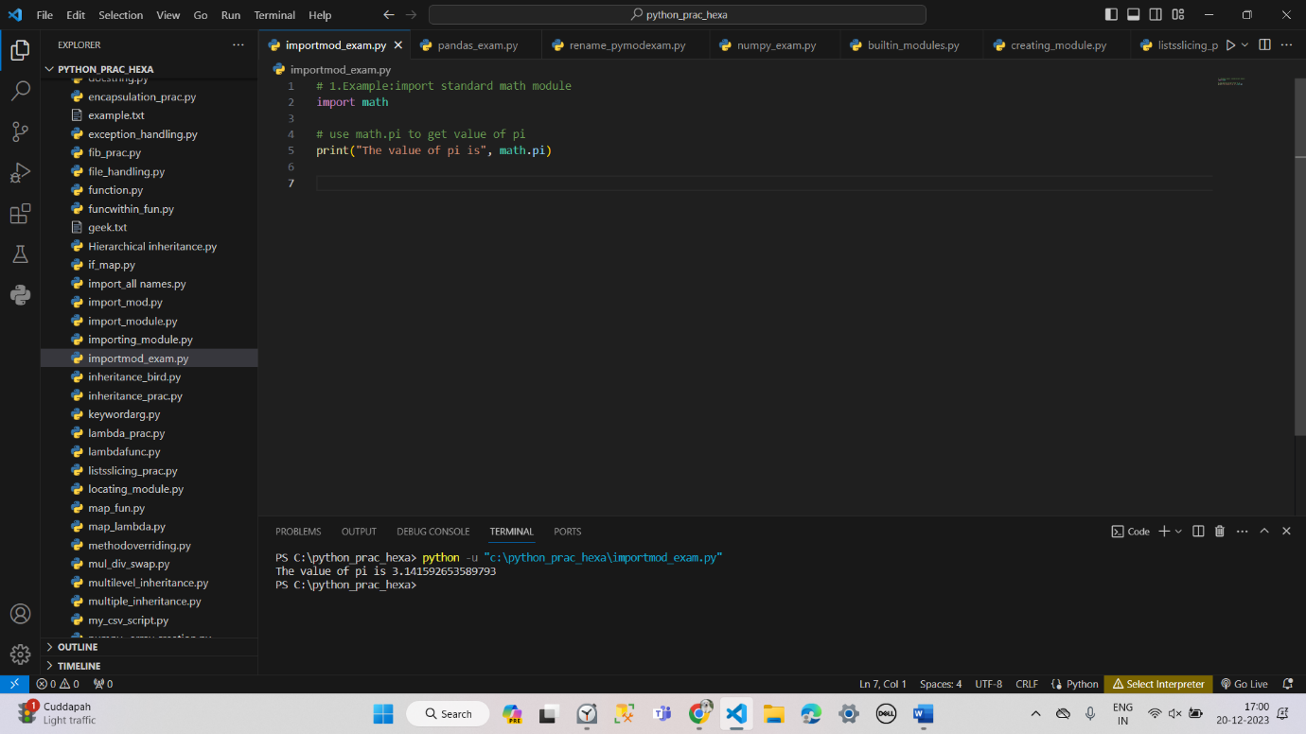

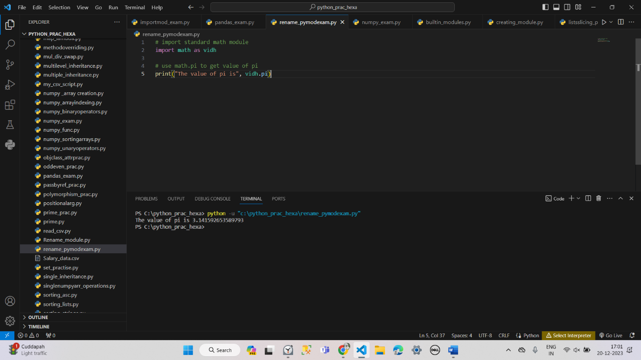

**Pandas:**

pandas is a python library used for working with datasets, it has several functions like analyzing, cleaning, exploring and manipulating data.

Pandas is most commonly used for data wrangling and data manipulation purposes, and NumPy objects are primarily used to create arrays or matrices that can be applied to DL or ML models.

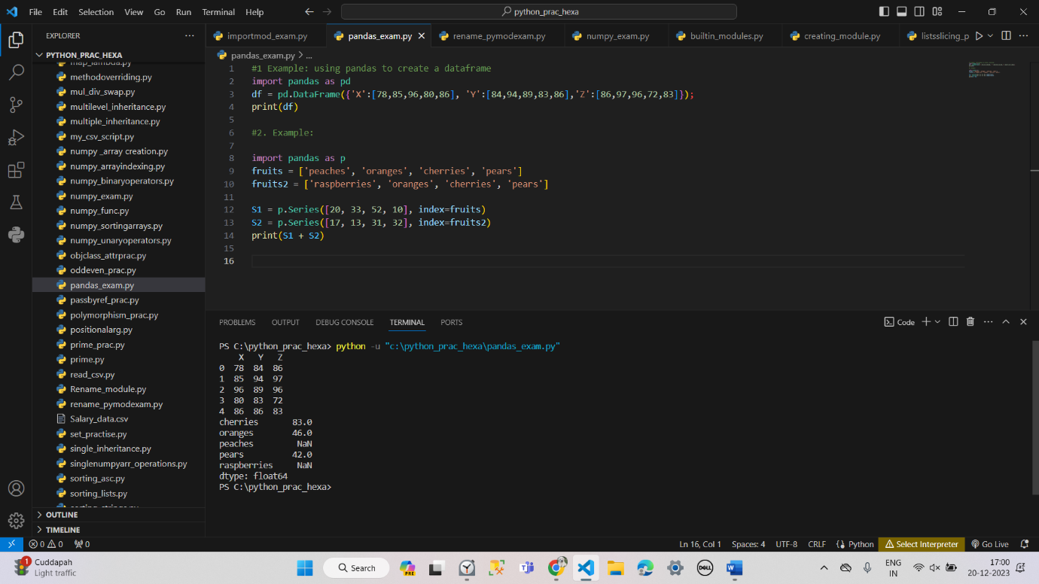

**NumPy:**

numpy is a general-purpose array processing package, it provides a high performance multi - dimesional array object and tools to work with arrays.

